**Project Screenshots**

1. 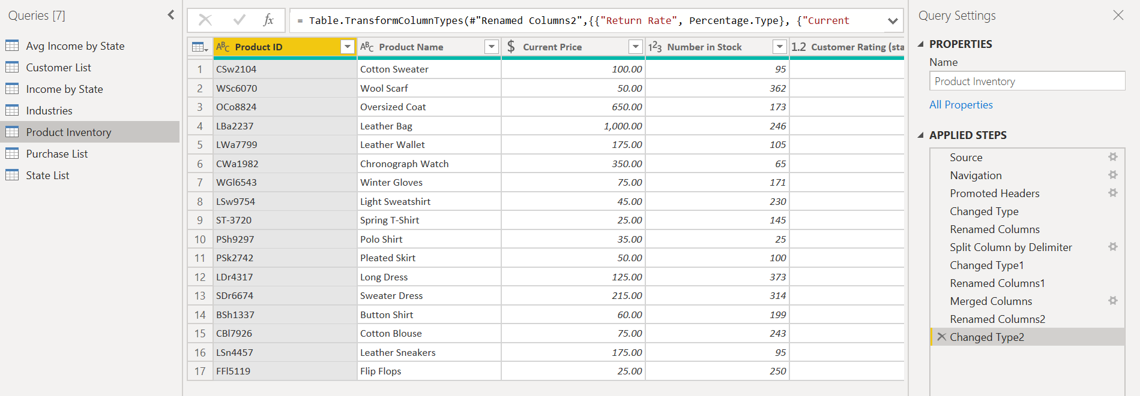Screenshots of Product Inventory Table and Applied Steps
2. 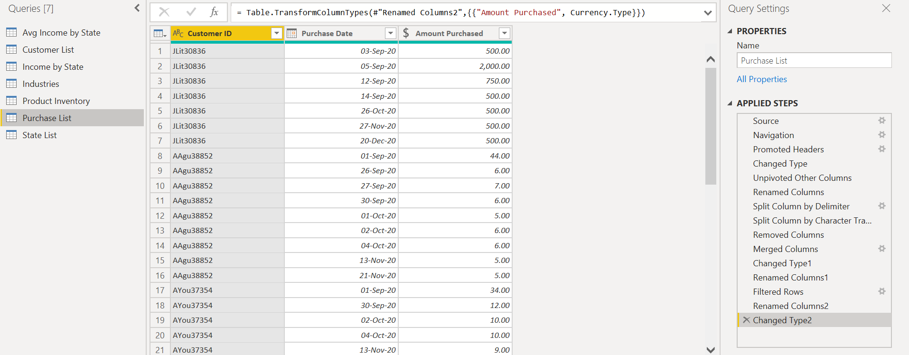Screenshots of Purchase List Table and Applied Steps
3. Screenshot of DAX formula – Income category

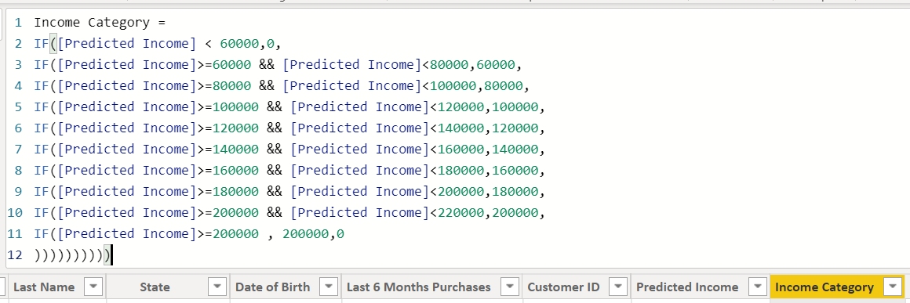

1. 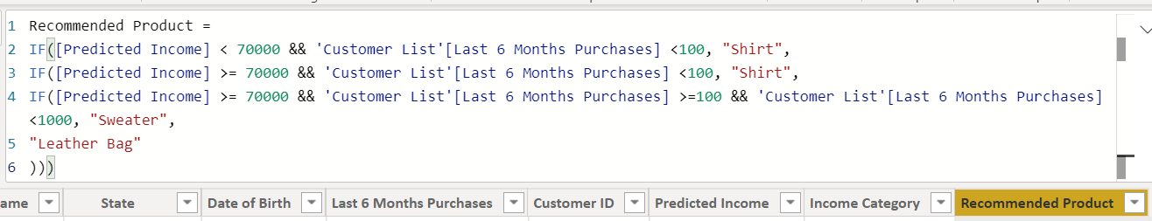Screenshot of DAX formula – Product Recommendation
2. 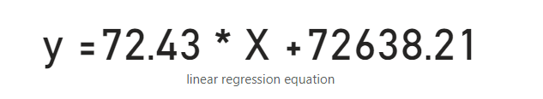Screenshot of the formula used to predict customer incomes based on the linear regression of sales and income
3. 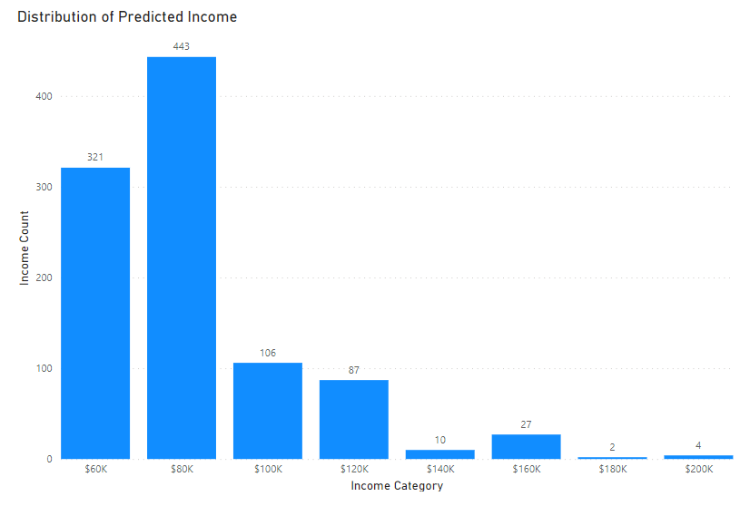Screenshot of histogram – Distribution and shape of predicted income
4. Screenshot of scatterplot and card

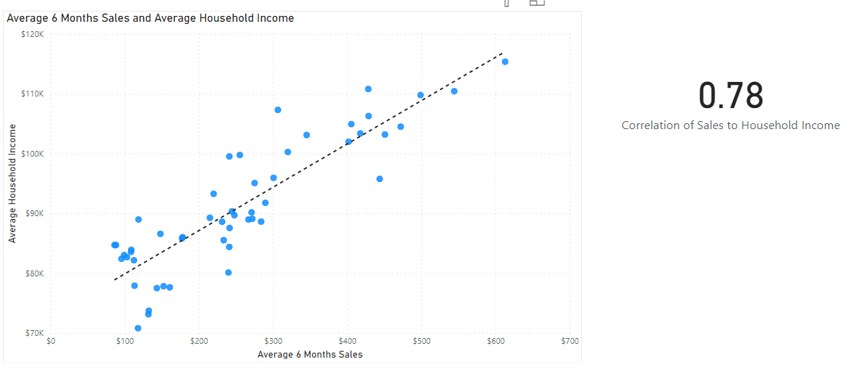

1. 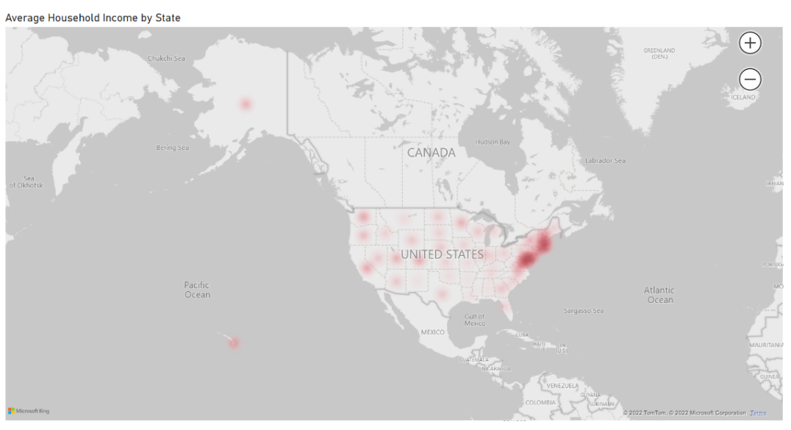Screenshot of the heatmap – Average household income by state
2. Screenshots of cross-filter
   1. 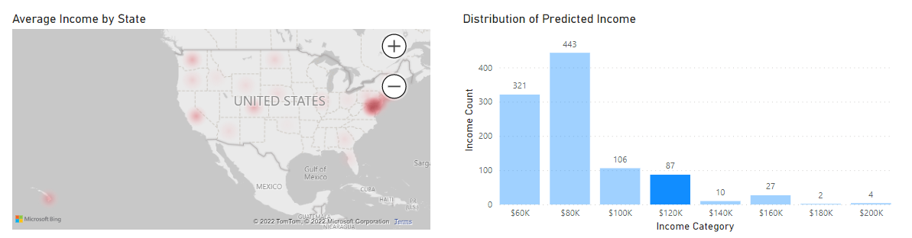Screenshot of cross-filtered histogram and heatmap
   2. 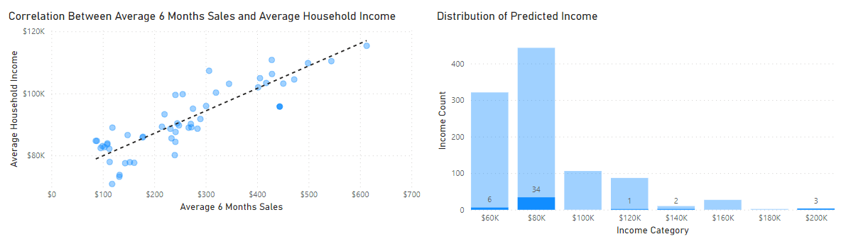Screenshot of cross-filtered scatterplot and histogram
   3. 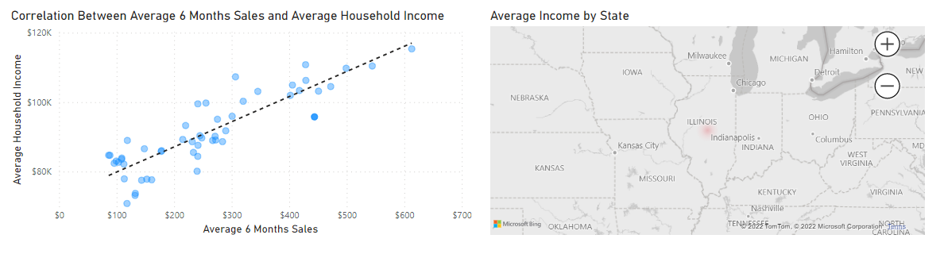Screenshot of cross-filtered scatterplot and heatmap